Report

Team ID | MCA
Project Name | Heart Disease Risk and Patient Health Analysis
Maximum Marks | 5 Marks

A report is a comprehensive document that provides a detailed and structured account of data analysis, findings, and insights. It is typically used for in-depth analysis, documentation, and communication of results. Reports are suitable for a diverse audience, including decision-makers, analysts, and stakeholders who need a comprehensive understanding of the data.
Designing a report in Power BI involves connecting to data sources, creating visualizations like charts and graphs, customizing their appearance and interactivity, organizing them logically on the canvas, formatting elements for consistency and clarity, and optionally creating dashboards for a summarized view. Throughout the process, it's essential to consider the audience's needs and ensure the report effectively communicates insights from the data. Finally, iterate based on feedback to continually improve the report's design and usefulness.

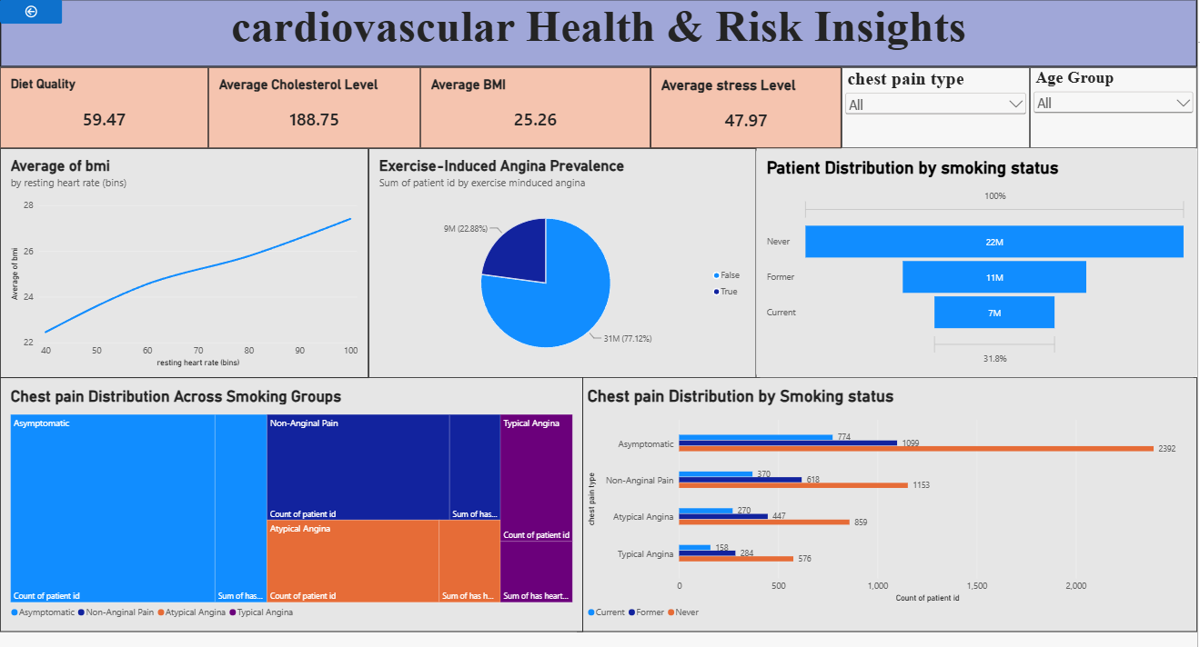
Observations Drawn from the Report
- BMI and Resting Heart Rate Trends: The line chart tracking the average of BMI by resting heart rate bins indicates a direct, upward positive correlation. As a patient's resting heart rate increases from 40 to 100 bpm, the average body mass index (BMI) scales up steadily from roughly 23 to nearly 27, suggesting metabolic or fitness links.
- Exercise-Induced Angina Prevalence: Among the sampled population, the vast majority do not experience exercise-induced chest pain. The pie chart reveals that 77.12% (31M patients) have no exercise-induced angina (False), while 22.88% (9M patients) experience it (True).
- Patient Distribution by Smoking Status: The patient demographic funnel chart shows that the largest segment of patients consists of those who have Never smoked (22M). This is followed by Former smokers at 11M, and Current active smokers represent the smallest segment at 7M.
- Chest Pain Distribution Across Smoking Groups: Across all smoking categories (Never, Former, Current), Asymptomatic presentations represent the absolute highest count of chest pain types (visualized broadly in the blue tree map and broken down with orange bars reaching 2,392 for non-smokers). Conversely, Typical Angina consistently represents the smallest segment of recorded chest pain types across all categories.

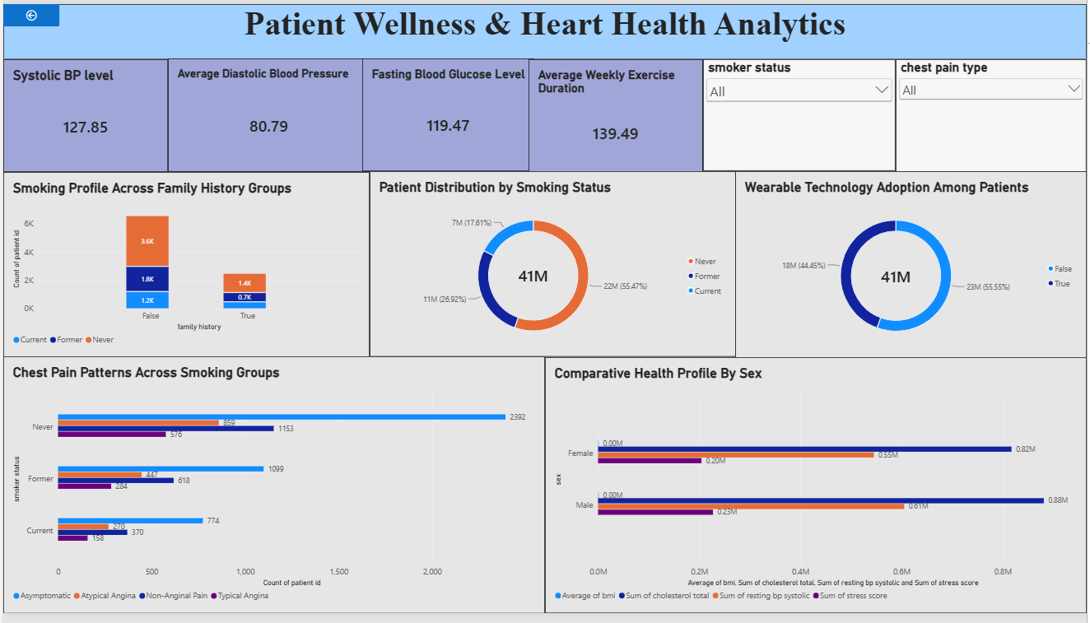

Key Observations Drawn from the Report
1. Patient Distribution by Smoking Status
The patient demographic breakdown indicates that the largest segment of the population consists of individuals who have Never smoked, making up 22M (55.47%) of the analyzed group. Former smokers account for 11M (26.92%), while active Current smokers represent the smallest clinical group at 7M (17.61%). This foundational distribution highlights a strong baseline of non-smoking individuals within the studied population.
2. Tech-Driven Health Engagement
Among the 41 million total patients, a significant majority are proactively tracking their health metrics. 23M (55.55%) patients have adopted wearable technology (True), while 18M (44.45%) do not utilize these devices (False). This high adoption rate suggests a major opportunity for healthcare providers to deploy remote health monitoring systems and app-based preventative care programs.
3. Clinical Vitals and Activity Performance
The report establishes baseline operational averages across the entire patient cohort:
- The average blood pressure trends toward pre-hypertension levels with a Systolic BP level of 127.85 and an Average Diastolic BP of 80.79.
- The Fasting Blood Glucose Level averages 119.47, pointing to a critical need for metabolic health screening.
- On a positive note, physical engagement is strong, with an Average Weekly Exercise Duration of 139.49 minutes, closely hitting international health guidelines for cardiac maintenance.
4. Chest Pain Typology Across Risk Groups
Analysis of symptomatic trends shows that across all smoking categories (Never, Former, Current), Asymptomatic presentations overwhelmingly represent the highest volume of cases, reaching a peak count of 2,392 cases among non-smokers. Conversely, Typical Angina consistently represents the smallest segment of recorded chest pain types across every demographic. This underscores a critical clinical reality: the absence of chest pain symptoms (asymptomatic status) does not completely rule out structural cardiac risks, emphasizing the value of proactive diagnostic screenings.
5. Family History Trends
When evaluating cross-generational risks, patients without a family history of heart disease (False) register higher absolute numbers across all smoking tiers—led by non-smokers at 3.6K. For patients with an active family history of cardiovascular complications (True), the overall volume is compressed, yet the internal behavioral distribution mirrors the baseline group with 1.4K never-smokers and 0.7K former smokers.
6. Comparative Health Profile by Sex
The comparative metrics reveal highly symmetric health profiles between sexes, though males display slightly elevated aggregate volumes. For both groups, the cumulative Sum of resting bp systolic and Sum of stress score is the most pronounced metric group (scaling to 0.82M for females and 0.88M for males). This is followed sequentially by total cholesterol sums (0.55M for females, 0.61M for males) and individual stress scores, signaling that macro cardiovascular stress loads remain uniform across genders.

